PT5220:
Unit identification and on-board programming.

1. Reference 2
2. Abstract 2
3. Control signals 2
4. V24 addresses 2
5. Identification 3
6. Factory programming 4
7. Custom programming, (upgrade) 5

Reference
[1]: “PTV’s XA Controller Board” by K. Engedahl rev. 1.0 23-09-1999

Abstract
The term unit is used throughout this document to specify any HW entity which can be programmed through a V24 interface.

The term program memory is used throughout this document to specify the flash EPROM device, which contains the microcontrollers program memory and a special boot/loader program located in a protected area.

Each unit should consist of a HW configuration based on the Philips XA microcontroller and a pre-programmed programmable flash EPROM device. Some additional logic is required in order to perform the on-board programming, see reference [1].

The microcontroller should use a 29,4912MHz crystal, and the V24 interface should be connected through serial port 1 on the controller, i.e. RxD1/TxD1.

Control signals
For programming and identification purposes the unit should be accessible through three control signals, namely /RESETn, ID_OPTIONn and PROGRAM.

/RESETn is used for resetting the unit, ID_OPTIONn is used to enable V24 communication to the unit. PROGRAM is used together with /RESETn to start the boot/loader program located in the program memory.

/RESETn and ID_OPTIONn are unique for each unit, while PROGRAM is common to all the units.

These three signals are used together with the V24 interface to identify and/or program the unit.

If one or more units share the same set of control signals, only the first unit should utilise PROGRAM.

V24 addresses
All the units are referenced by using the multiprocessor communication system built into the XA microcontroller.

All the units must default to a V24 address after /RESETn. If one or more units share the same set of control signals, each unit should default to successive addresses following the first unit.

The default V24 address is address 0F0_{hex}, which makes it possible for 16 units to share the same set of control signals, e.g. if three units share the same set of control signals, they should default to address 0F0_{hex}, and the successive addresses 0F1_{hex} and 0F2_{hex}.

The XA Controller Board will assign new addresses to the units, once they have been adddressed for the first time.

Some of the units, namely those placed on the sync back plane, will have preassigned addresses, and will not need to reset to these addresses.

Identification
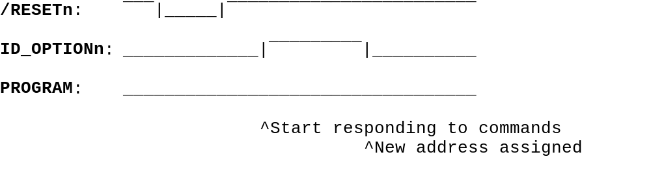After /RESETn has been released the unit should reset to its default address. It should however NOT reply to any commands issued to this address until ID_OPTIONn becomes active.

When ID_OPTIONn becomes active the unit should reply to any commands issued to its address.

One of these commands will assign a new address to the unit.

After having been assigned a new address, the unit should reply to all commands issued to this address, no matter the state of ID_OPTIONn, i.e. ID_OPTIONn constitutes a “don’t care” signal for communicating with the unit once it has been assigned a new address.

In pseudo-C this identification can be expressed as;

Main() {
V24_address = default_addr;
REPLY_FLAG = FALSE;
Disable V24 communication;

Do some option initialising etc;

Do {
If ( ID_OPTIONn)
REPLY_FLAG = TRUE;
} While ( REPLY_FLAG == FALSE);

Enable V24 communication;

While (TRUE) {
}
}

Factory programming
When the unit is delivered from the factory it will contain a blank program memory except for a special boot/loader program located in a protected area of the program memory, (see reference [1]). Notice that the program memory could also be blank/invalid due to some error during (re)programming.

In either cases it is necessary to activate the boot program in order to communicate and program the unit. It is however not possible to get information about the unit type as the boot program is generic to all processor systems using this particular flash device, hence it does not contain any information about a specific unit type.
It is therefore necessary to tell the XA Controller Board controller the type of the unit placed on any of the general purpose connectors. This information should be given through a remote command to the XA master controller, or through a selection on the front panel.

The XA Controller Board is aware of units which is an integrated part of the basic PT5220 due to the implementation of the unique control signals /RESETn and ID_OPTIONn, therefore it is not necessary to tell the XA master controller the type of these units. These units includes the oscillator unit and the Time Clock Interface.

The communication during programming will be standard V24 programming, i.e. it will not utilise the multiprocessor communication scheme used during normal unit communication. For this reason it is important to disable any other unit in the setup by activating the /RESETn line. The reason for this approach is due to the fact that the units and any other hardware configuration based on this particular flash EPROM device also should be programmable from a PC, which is not capable of handling the multiprocessor communication scheme.

To initiate the boot/loader program a /RESETn should be issued to the unit. While /RESETn is active, the signal PROGRAM should be set active. When releasing /RESETn, the state of PROGRAM will force the processor to activate the boot/loader program located in the upper program memory.

Activating the PROGRAM signal will XOR the upper three address bits with ‘1’. When the /RESETn is released the processor will execute the program found at address 0_{hex}, but since the upper three upper address bits has been XOR’ed with ‘1’, the program will be executed from address E0000_{hex} in the program memory.

This boot/loader program will intialise V24 variables, programming APIs etc., and the unit is ready for programming through the V24 interface.

For a more detailed explanation and how to program the unit, see reference [1].

If one or more units share the same set of control signals, only the first unit can be programmed directly. To program any of the other units, the first unit must be used to generate the appropriate signals.

Custom programming, (upgrade)
Whenever an unit has to be upgraded, or altered in any way, the XA master controller already knows the type of the unit, therefore it is not necessary to tell the XA master controller which unit is placed on the connector. The XA master controller will then store information about the unit type before commencing the programming sequence. In this way the XA master controller will know the unit type, even if the configuration is interrupted, thereby making it possible to restart the configuration Without having to enter the unit type.

The programming is otherwise identical to the factory programming, including the fact that all units besides the one being programmed has to be disabled.

